**CAREER ADVISORY SYSTEM-NLP**

**Assignment-5**

**Artificial Intelligence- CSE643**

PREPARED BY

**Bhavishi Bansal**

**(SP22001)**

FACULTY GUIDES

**C. Anantaram**



**Computer Science and Engineering**

**Indraprastha Institute of Information Technology Delhi**

**DECEMBER, 2022**

**1 Introduction**

This Career Advisory System can be useful for graduating student and will recommend career options based on user’s interest,courses he had done related to that field and average gpa he scored in that courses. Python code creates a fact which stores the name of the user. Named Entity Recognition is implemented for this. Initially, the user is asked to introduce himself/herself. Then, sentence tokenisation followed by word tokenisation, POS tagging, creating named entity chunks and to extract the chink with PERSON label. Finally, the person's name is extracted and saved as a fact in a text file.

Prolog code runs as before. Now, in the final result of career advise is given with using the name of the user.

**2 Python Code**

import nltk

from nltk.tokenize import word_tokenize

from nltk.tokenize import sent_tokenize

from nltk.tag import pos_tag

response = input("Hi, Please introduce yourself: ")

sentences = sent_tokenize(response)

token_sentences = [word_tokenize(sentence) for sentence in sentences]

tag_sentences = [pos_tag(sentence) for sentence in token_sentences]

name=''

for sentence in tag_sentences:

for chunk in nltk.ne_chunk(sentence):

if type(chunk)==nltk.tree.Tree and chunk.label()=='PERSON':

name = chunk[0][0]

break

f = open('C:/Users/hp/career_facts.txt', 'w')

if name == '':

f.write('name_person(user).')

else:

f.write('name_person('+name.lower()+').')

f.close()

**3 PROLOG Code**

init :-

consult('C:/Users/hp/career_facts.txt'),retractall(response(_,_)), option(Career),!, printmsg(Career), nl, fail.

init :-

write(''),nl,

write('Welcome to Elective Advisory System.'),nl,

write(''),nl,

write('Can I know your good name? write your name in inverted commas)'),

read(Name),nl,

format('Hi, ~w. Let\'s explore the elective options.',[Name]),nl,

write(''),nl,fail.

init :-

retractall(response(_,_)), option(Career),!, printmsg(Career), nl, fail.

/* To check if required values, i.e, either 0 or 1, are inserted by the user.*/

read_response(Response) :-

read(TmpResponse), (TmpResponse = 0; TmpResponse = 1),!, Response = TmpResponse;(write('Invalid Response'), nl, read_response(Response)).

/* Questions for user */

query(1,A1):- write('Which semester, monsoon or winter, will you be in?:write 1 for monsoon, 0 for winter'),nl,read_response(A1),assert(response(1,A1)).

query(2,A2):- write('Have you done M1 course:Linear Algebra;write 1 for yes, 0 for no'),nl, read_response(A2),assert(response(2,A2)).

query(3,A3):- write('have you done probability and statistics course;write 1 for yes, 0 for no'),nl, read_response(A3),assert(response(3,A3)).

query(4,A4):- write('have you done Intro to Programming course; write 1 if yes, 0 for no'),nl, read_response(A4), assert(response(4,A4)).

query(5,A5):- write('Have you done M3 course:Multivariate Calculus;write 1 for yes, 0 for no.'),nl,read_response(A5), assert(response(5,A5)).

query(6,A6):- write('Have you done Data structure and algorithms;write 1 for yes, 0 for no'),nl,read_response(A6),assert(response(6,A6)).

query(7,A7):- write('Do you have intrest in developing supervised and unsupervised models; write 1 for yes, 0 for no'),nl,read_response(A7), assert(response(7,A7)).

query(8,A8):- write('Have you done discrete mathematics course;write 1 for yes, 0 for no'),nl,read_response(A8), assert(response(8,A8)).

query(9,A9):- write('Do you have intrest in Artificial Intelligence:?write 1 for yes, 0 for no'),nl,read_response(A9), assert(response(9,A9)).

query(10,A10):- write('Have you studied probability and random processes:?write 1 for yes, 0 for no'),nl,read_response(A10), assert(response(10,A10)).

query(11,A11):- write('Do you have basic understanding of biology;write 1 for yes, 0 for no'),nl,read_response(A11), assert(response(11,A11)).

query(12,A12):- write('Dou you know C/C++ programming:?write 1 for yes, 0 for no'),nl,read_response(A12), assert(response(12,A12)).

query(13,A13):- write('Do you have intrest in computer graphics:?write 1 for yes, 0 for no'),nl,read_response(A13), assert(response(13,A13)).

query(14,A14):- write('Have you done digital circuits course:?write 1 for yes, 0 for no'),nl,read_response(A14), assert(response(14,A14)).

query(15,A15):- write('Do you have intrest in how different processors work:?write 1 for yes, 0 for no'),nl,read_response(A15), assert(response(15,A15)).

query(16,A16):- write('Have you done database management course:?write 1 for yes, 0 for no'),nl,read_response(A16), assert(response(16,A16)).

query(17,A17):- write('Have you done java programming:?write 1 for yes, 0 for no'),nl,read_response(A17), assert(response(17,A17)).

query(18,A18):- write('Do you have basic knowledge of set theory:?write 1 for yes, 0 for no'),nl,read_response(A18), assert(response(18,A18)).

query(19,A19):- write('Do you have intrest in graph theory?write 1 for yes, 0 for no'),nl,read_response(A19), assert(response(19,A19)).

/* to see if the question has previously been asked.*/

check(Value,Res):- response(Value,Res),!.

check(Value,Res):- query(Value,Res).

/* Based on user's different responses option command will choose which quey to ask next */

option(ml) :-

(( query(1,A1), A1=1, query(2,A2), A2=1, query(3,A3), A3=1, query(4,A4), A4=1, query(5,A5), A5=1,query(7,A7), A7=1);

( response(1,A1), A1=1, check(2,A2), A2=1, check(3,A3), A3=1, check(4,A4), A4=1 ,response(5,A5),A5=1 )).

option(ai) :-

(

( response(1,A1), A1=1, query(6,A6), A6=1, query(8,A8), A8=1, query(9,A9), A9=1);

( response(1,A1), A1=1, check(6,A6), A6=1, check(9,A9), A9=1) ).

option(network_biology):-

( ( response(1,A1), A1=1, query(6,A6), A6=1, query(4,A4), A4=1, query(11,A11), A11=1);

( response(1,A1), A1=1, check(11,A11), A11=11) ).

option(communication_network):-

( ( response(1,A1), A1=0, query(3,A3), A3=1, query(10,A10), A10=1);

( response(1,A1), A1=0, check(3,A3), A3=1) ).

option(computer_graphics):-

( ( response(1,A1), A1=1, query(4,A4), A4=1, query(6,A6), A6=1, query(12,A12), A12=1, query(13,A13), A13=1);

( response(1,A1), A1=1, response(4,A4), A4=1,response(6,A6), A6=1, response(13,A13), A13=1);

( response(1,A1), A1=1, response(4,A4), A4=1,response(12,A12), A12=1, response(13,A13), A13=1) ).

option(computer_organization):-

( ( response(1,A1), A1=0, query(14,A14), A14=1, query(15,A15), A15=1);

( response(1,A1), A1=0, check(14,A14), A14=1)).

option(data_mining):-

( ( response(1,A1), A1=1,query(2,A2), A2=1, query(3,A3), A3=1,query(4,A4),A4=1,query(16,A16),A16=1,query(17,A17),A17=1);

( response(1,A1), A1=1, query(4,A4), A4=1, query(2,A2), A2=1, query(3,A3), A3=1, query(16,A16), A16=1) ).

option(intro_math_logic):-

( ( response(1,A1), A1=0, query(18,A18), A18=1, query(8,A8), A8=1);

( response(1,A1), A1=0, check(18,A18), A18=1) ).

option(graph_theory):-

( ( response(1,A1), A1=0, response(2,A2), A2=1, query(8,A8), A8=1, query(19,A19), A19=1);

( response(1,A1), A1=0, check(2,A2), A2=1,check(19,A19),A19=1);

( response(1,A1), A1=0, check(8,A8), A8=1,check(19,A19),A19=1)).

/* printmsg will print elective name according to user's response*/

printmsg(ml) :-

write('You should explore Machine Learning based on the answers to the several question asked.'), nl.

printmsg(ai) :-

write('You should explore Artificial Intelligence based on the answers to the several question asked.'), nl.

printmsg(network_biology) :-

write('You should explore Network Biology based on the answers to the several question asked.'), nl.

printmsg(communication_network) :-

write('You should explore Communication Network based on the answers to the several question asked.'), nl.

printmsg(computer_graphics) :-

write('You should explore Computer Graphics based on the answers to the several question asked.'), nl.

printmsg(computer_organization) :-

write('You should explore Computer Organization based on the answers to the several question asked.'), nl.

printmsg(data_mining) :-

write('You should explore Data Mining based on the answers to the several question asked.'), nl.

printmsg(intro_math_logic) :-

write('You should explore Introduction to Mathematical Logic based on the answers to the several question asked.'),nl.

printmsg(graph_theory) :-

write('You should explore Graph Theory based on the answers to the several question asked.'), nl.

**Output screenshot**

First of all program ask for user’s introduction.

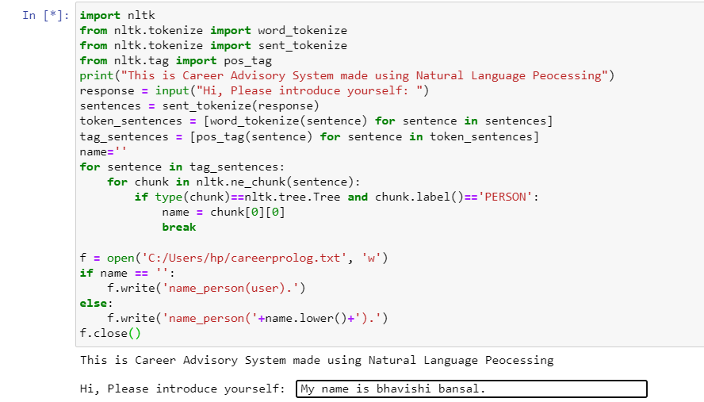

Then it will ask for further question related to different career field in prolog based on the name stored in temp file.

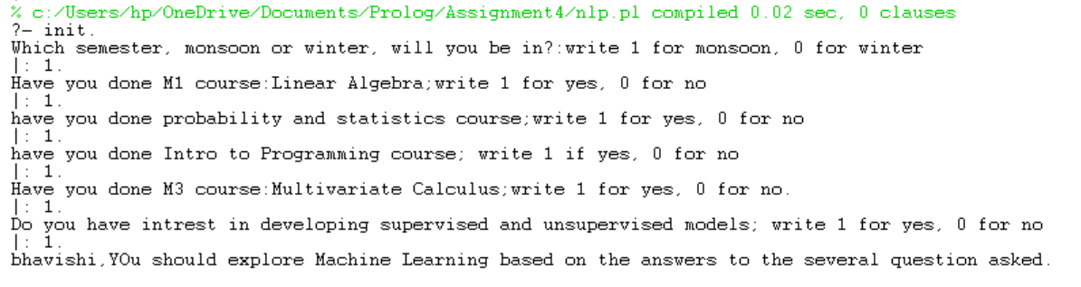

Another output with different user introduction

